**Business problem**

Create a model that groups the customers of a specific mall by their annual income and their spending on that mall.

**Explaining the model**

1. Import the dataset, which is in a csv format.
2. We use the columns of interest, which are the annual income and spending.
3. After that, we need to know the optimal number of clusters. To do so, we create an empty vector and we iterate it. After that, we plot the graph to get the optimal number.

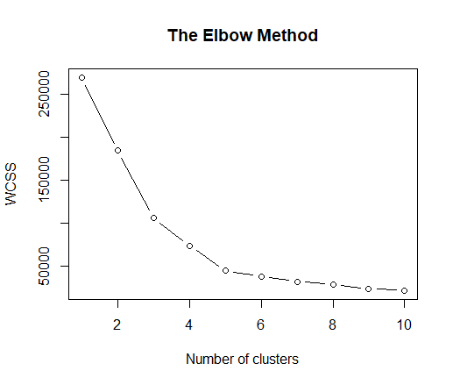

1. We can see from the graph that the optimal number of clusters for our dataset is 5.

**Plotting the results**

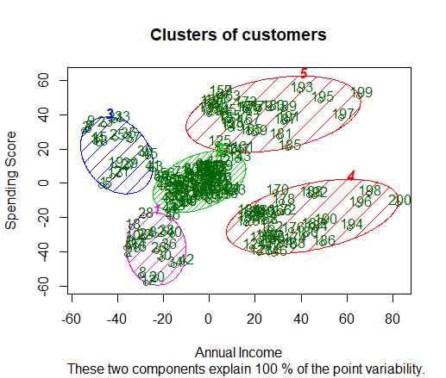

As we can see, we got our 5 clusters. Cluster number 1 is the cluster with the customers with low income and low spending. Cluster number 2 is the cluster with the customers with average income and average spending. Cluster number 3 is the cluster with the customers with low income and high spending. Cluster number 4 is the cluster with the customers with high income and low spending. Cluster number 5 is the cluster with the customers with high income and high spending.